**[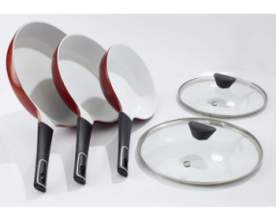](javascript:PopupImage('../jpg/010/5/010540_1.jpg'))**